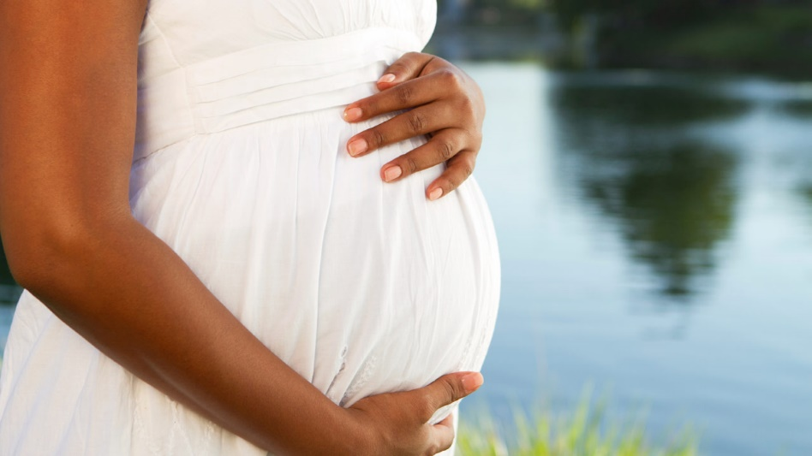
A Pregnant
Woman
Is Not Autonomous and
the Placenta Knows It!

A pregnant woman is not autonomous.
Her pregnancy is not "a cancer."
And the placenta knows it!
When serving as president of National Lutherans For Life, I had long discussions with my Ob/Gyn friend, Karen Rehder, M.D. I've never forgotten what Karen told me: "Birth is a miracle. Were it not for the placenta, the mother would reject the baby as something foreign to her body just like a transplant patient rejects a liver or kidney."
Two separate entities—baby and mother—are attached by umbilical cord and placenta. The placenta tells us that a pregnant woman is not autonomous.
The placenta "is the only organ made in cooperation by two people," explains Dr. Kristin Collier. It is "the organ through which the baby and mother interface." Dr. Collier is Assistant Professor of Internal Medicine at the University of Michigan Medical School and practices general Internal Medicine. She also serves as Director of the U of Michigan’s Medical School program on Health, Spirituality, and Religion.
The placenta, "made from the growing baby's tissue and the mother's tissue together . . . is known as a 'feto-maternal' organ . . . [that] helps provide nutrition, produces hormones, and protects the baby against infection." This “purposely transient organ” acts like “a lung, kidney, gastrointestinal tract, and the endocrine and immune system.”
The placenta is so important that the National Institutes of Health (NIH) in the U.S. has a research arm called the Human Placenta Project. A “healthy placenta is not only crucial for healthy development of the prenatal child, but also affects the health of the child and mother for years to come.”
There is “a unique transfer of cellular materials that happens across the placenta. In science, microchimerism refers to the presence of a small population of genetically distinct and separately derived cells within an individual. In pregnancy, small amounts of cells travel across the placenta. Some of these cells are the prenatal child’s cells that travel from the baby into her mother, and some cells also pass from the mother into her child. The cells from the prenatal child into her mother are pluripotent, which means they haven’t yet differentiated into the type of cell specific for one organ or tissue in particular. These cells find their way into mother’s tissue and start acting like the tissue in which they find themselves. This process is known as feto-maternal microchimerism.”
Scientifically, we can say that mother is helped by her unborn baby. “For example, these [fetal] cells have been found in Caesarean sections incisions helping to make collagen to help mom heal after a surgical delivery. These cells have been found in the maternal breast and have been hypothesized to help reduce mom’s risk of breast cancer in her later years.”
The “gift of these cells from the baby, entering into mom’s body and helping her heal and protecting her from cancer, is amazing to think of and really challenges our ideas of people as autonomous beings.” Just as amazing is the fact that “these cells that enter the mother are allowed to survive and are not attacked by the mother’s immune system, even though they are somewhat ‘foreign.’ This again speaks to a cooperation, at the cellular level, between mother and child.”
This science sheds new light on the abortion debate. “Every dehumanizing ideology succumbs to the same temptation—to see the undesirable other as a non-person. In the abortion debate, as in similar debates around marginalized vulnerable populations, language is used when describing the undesirable other that is dehumanizing. In the abortion debate, the prenatal child is referred to as a ‘clump of cells’ or even a ‘parasite.’” We must “resist appeals to individual autonomy that detach us from our duty to aid others, and resist language, practices, and social structures that detach us from the full reality and dignity of . . . marginalized [persons]. A radical view of autonomy that leads to the end of another human life is one that is anti-life and oppresses the rights of another in the name of ‘freedom.’"
Dr. Collier admits that she is not a theologian, but she encourages us to think of biology “in a relational sense that mirrors the nature of God. The scriptures speak of a God who is in relationship with his people. We then would only expect that God, being the author of biology, would create our bodily nature in a way that was also relational—even down to the level of the cell.” Dr. Collier draws our attention to the “cells from the incarnate word of God, Jesus Christ, in his mother, the Virgin Mary [who] not only carried the Son of God in her body when he was in her womb, but . . . likely carried his cells in her body throughout her life . . .”
It is a loss to the human family when we pervert the language of conception and pregnancy. May we instead share God's hope for mother and child revealed through the miracle of the placenta. A baby in the womb is not "a cancer"—and the placenta knows it!
by Linda Bartlett 2-16-20
(Source: “Together, baby; forever, baby,”
an interview by Carolyn Moynihan with Dr. Kristin Collier
in MercatorNet.com, 2-5-20)

